**How to Install GitKraken Client**

There are three steps to success with GitKraken Client. That’s it!

1. [Download](https://gitkraken.com/download) GitKraken Client
2. Install GitKraken Client
3. Use GitKraken Client

No Git tools are required for GitKraken Client, so once you’ve run the installer, you can open the app and get going.

If you want to utilize additional features such as the terminal or LFS, [download git-scm](https://git-scm.com/).

Below are platform-specific instructions and details on minimum requirements.

Looking for *GitKraken Enterprise Self-Hosted* installation instructions? Then please start in with our [Enterprise System Requirements](https://help.gitkraken.com/enterprise/system-requirements) page.

**Windows (.exe file)**

* **System requirements:** Windows 10
* [Download (64-bit)](https://gitkraken.com/download/windows64)
* [Download (32-bit)](https://gitkraken.com/download/windows)

**Install Instructions**

Double-click the downloaded executable file. You will see a splash screen while GitKraken Client is insalled, and then the application will automatically start.

**Data Location**

GitKraken Client data is stored with your home profile in C:\Users\{user}\AppData\Roaming in the .gitkraken folder.

**Mac OS (.dmg file)**

* **System requirements:** Mac OS X 10.11+
* [Download](https://gitkraken.com/download/mac)

**Install Instructions**

Double click the downloaded DMG file and when prompted, drag and drop the GitKraken icon to your Applications folder.

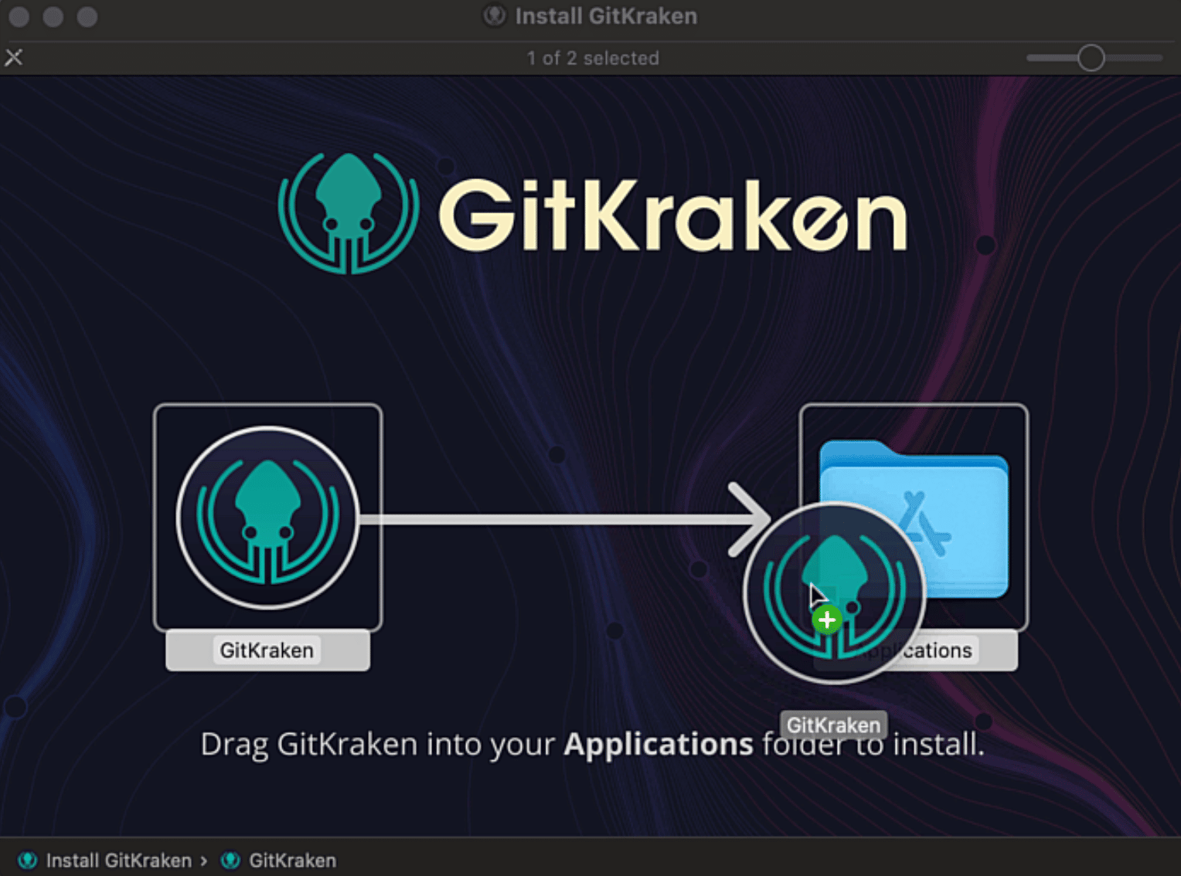

**Data Location**

GitKraken Client data is stored in /Users/{user}/.gitkraken == ~/.gitkraken.

**Linux (.deb, .rpm, and .tar.gz files)**

* **.deb system requirements:** Ubuntu 18.04 LTS or later
* **.rpm system requirements:** RHEL 7+, CentOS 7+, or Fedora 34+

Note 📝 – GitKraken Client currently supports Ubuntu 18.04 LTS+, RHEL 7+, CentOS 7+, and Fedora 34+. While GitKraken Client may be able to be installed on other Linux distributions, we cannot guarantee that it will work as expected.

**.deb**

GitKraken Client has a simple package available for Debian based distributions.

wget https://release.gitkraken.com/linux/gitkraken-amd64.deb

sudo dpkg -i gitkraken-amd64.deb

Or [download the file](https://gitkraken.com/download/linux-deb).

**.tar**

wget https://release.gitkraken.com/linux/gitkraken-amd64.tar.gz

sudo tar -xvzf gitkraken-amd64.tar.gz

Or [download the file](https://gitkraken.com/download/linux-gzip).

**.rpm**

wget https://release.gitkraken.com/linux/gitkraken-amd64.rpm

sudo yum install ./gitkraken-amd64.rpm

Or [download the file](https://gitkraken.com/download/linux-rpm).

**Snap**

Snap is an easy-to-install package for Linux distributions (supported versions above). Get it from the snap store or [Snapcraft.io](https://snapcraft.io/gitkraken).

**Data Location**

GitKraken Client data is stored in /home/{user}/.gitkraken == ~/.gitkraken.

**Run GitKraken Client**

Upon installation, some Linux distros do not automatically create shortcuts to the app.

To run GitKraken Client manually, open the terminal and type gitkraken to start the app.